# CS 255 System Design Document

## UML Diagrams

### UML Use Case Diagram

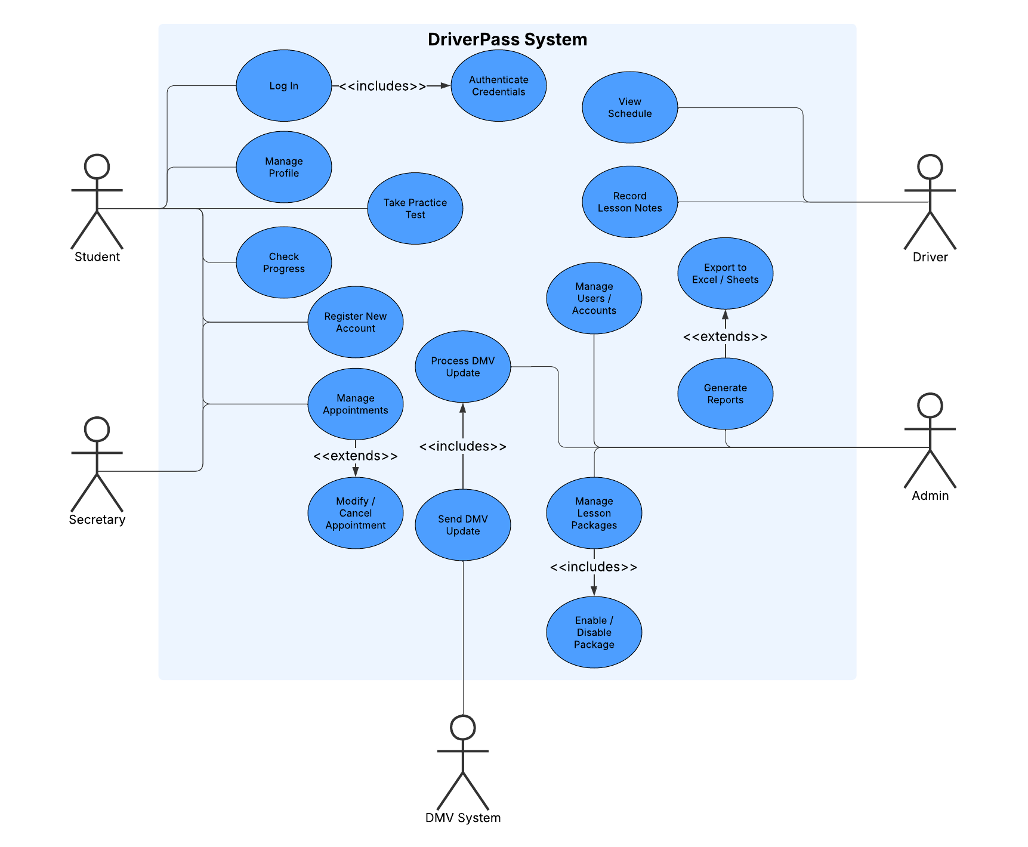

### UML Activity Diagrams

### UML Sequence Diagram

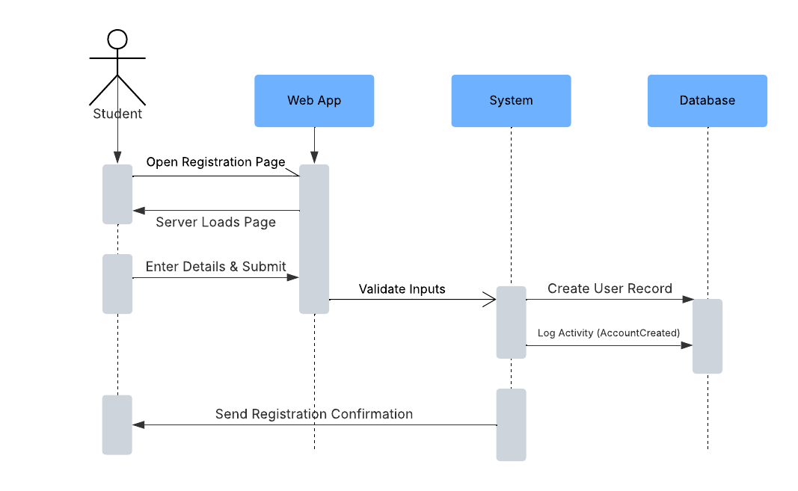

### UML Class Diagram

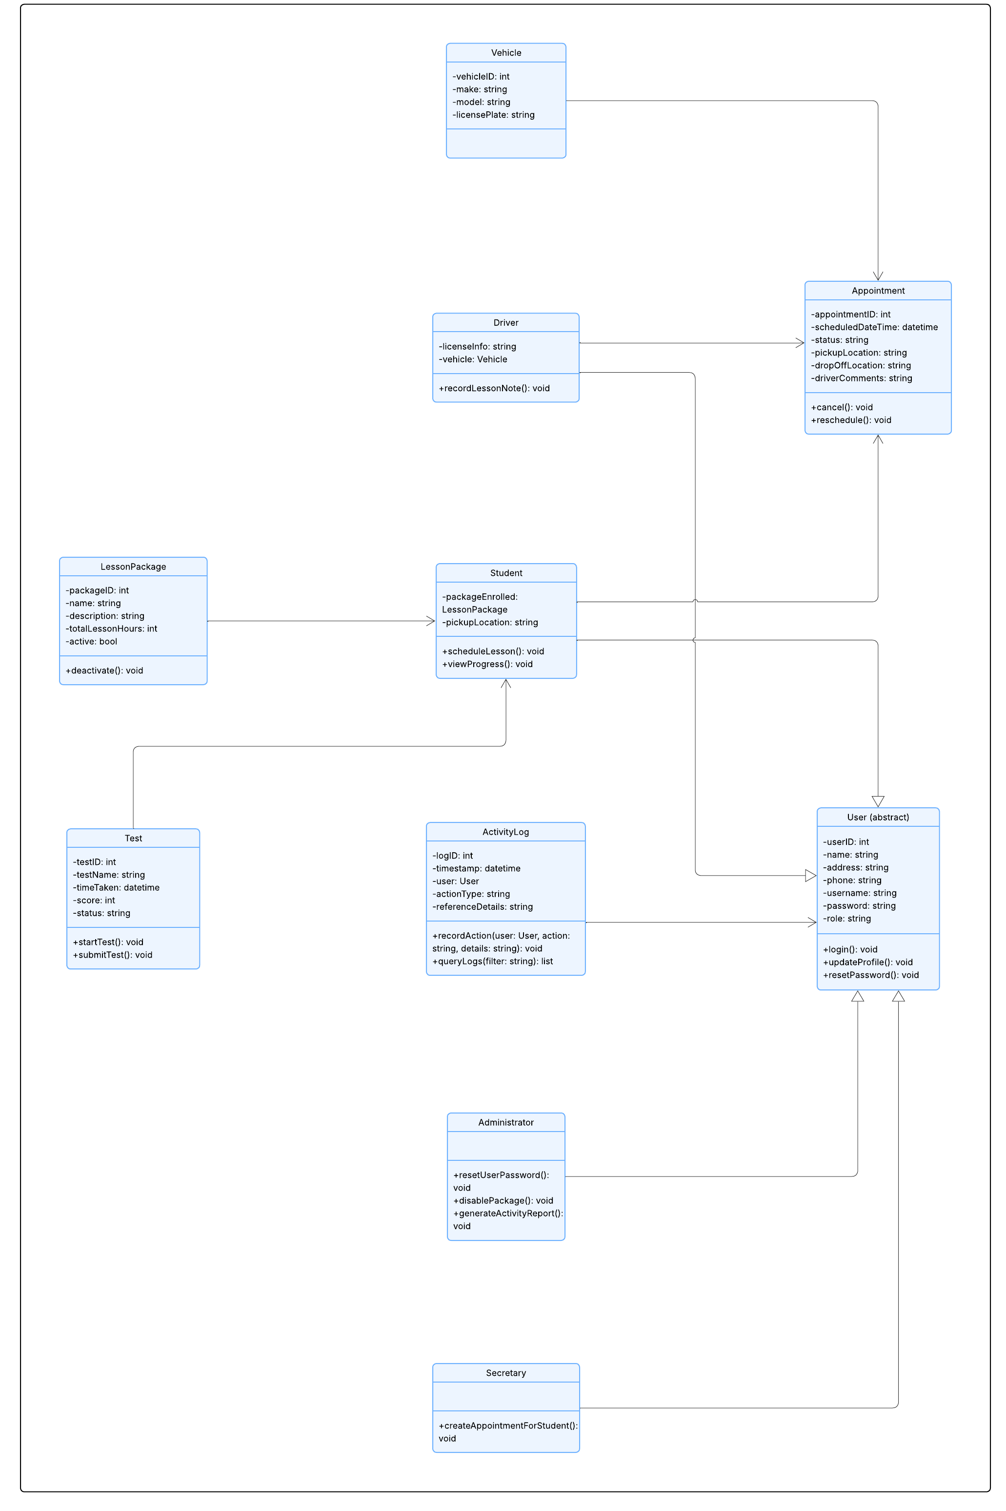

## Technical Requirements

The DriverPass system will operate as a cloud-hosted, three-tier web application accessible via major desktop and mobile browsers. End-users require only standard internet-connected devices, while the backend will run in containerized services with a relational database for accounts, scheduling, lessons, test attempts, and logging. The system must enforce role-based access control (Student, Secretary, Driver, Administrator), secure credential handling with strong password policies and MFA, and TLS encryption for all communication. Key infrastructure includes a load balancer, private networked data stores, and integrations with notification services (email/SMS) and DMV update feeds. Activity logs must be immutable and auditable by administrative users (Owner / IT officers), and exports (reports, schedules, test results) available in Excel/CSV formats. Supporting tools include CI/CD pipelines for automated testing and deployment, cloud monitoring and alerting for performance and security, and backup/DR capabilities for high availability and redundancy.